**Comments and Test Case Screenshots**

**Exercise 10.6 : Display Prime Numbers**

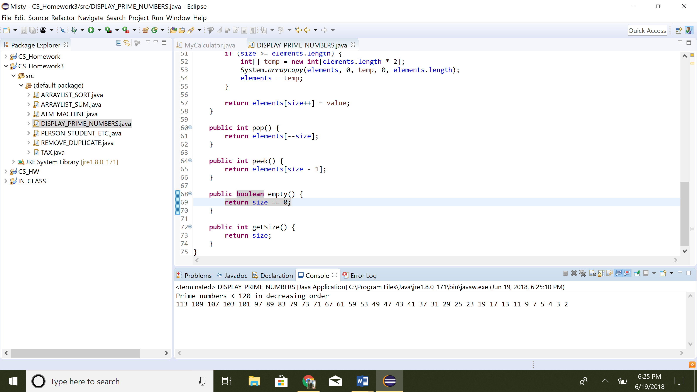

1. Display all prime numbers < 120 in decreasing order
2. Use StackOfIntegers class to store prime numbers

**Exercise 10.7 : ATM Machine**

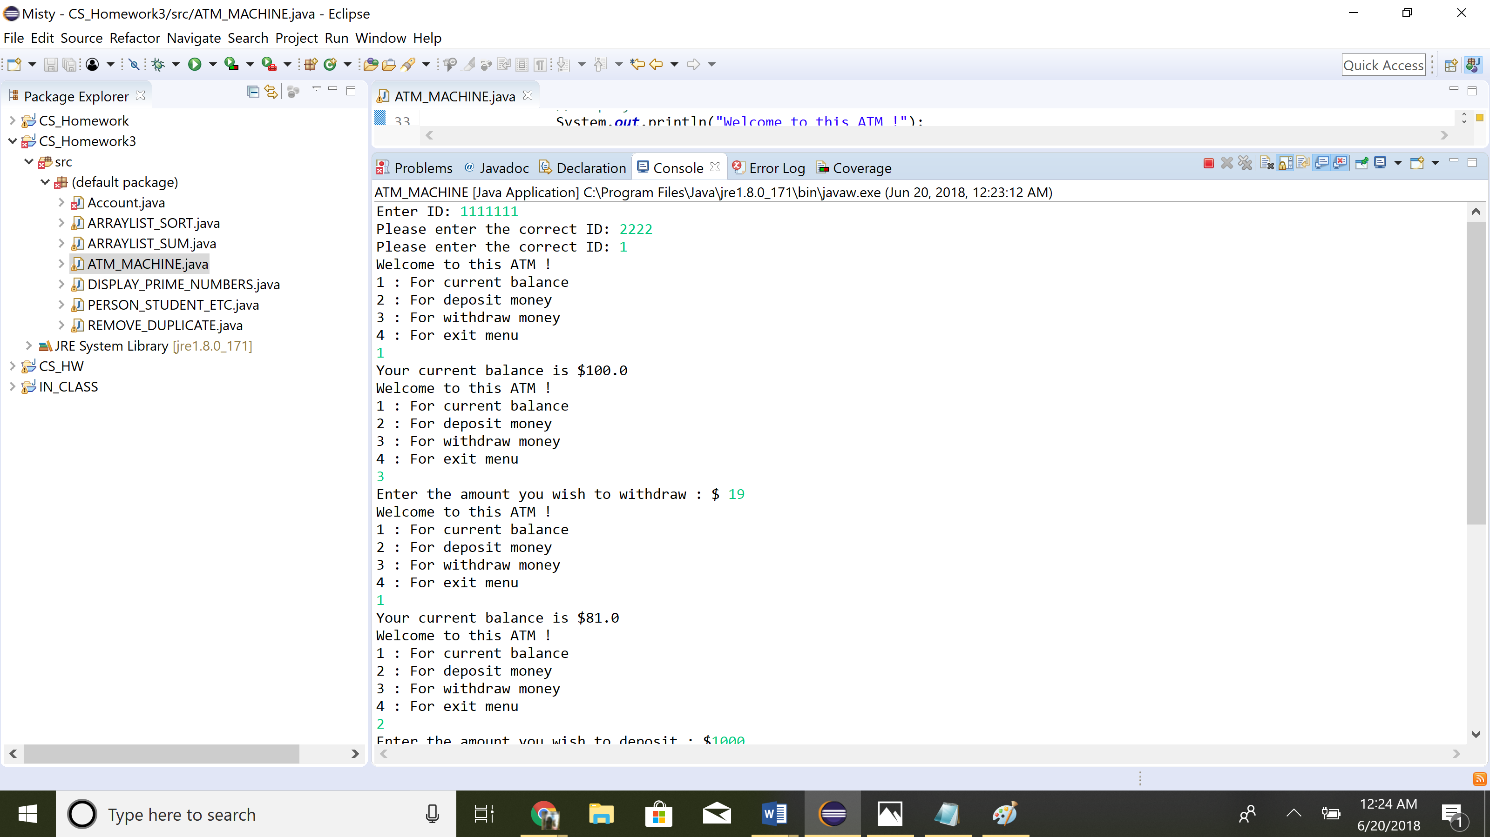

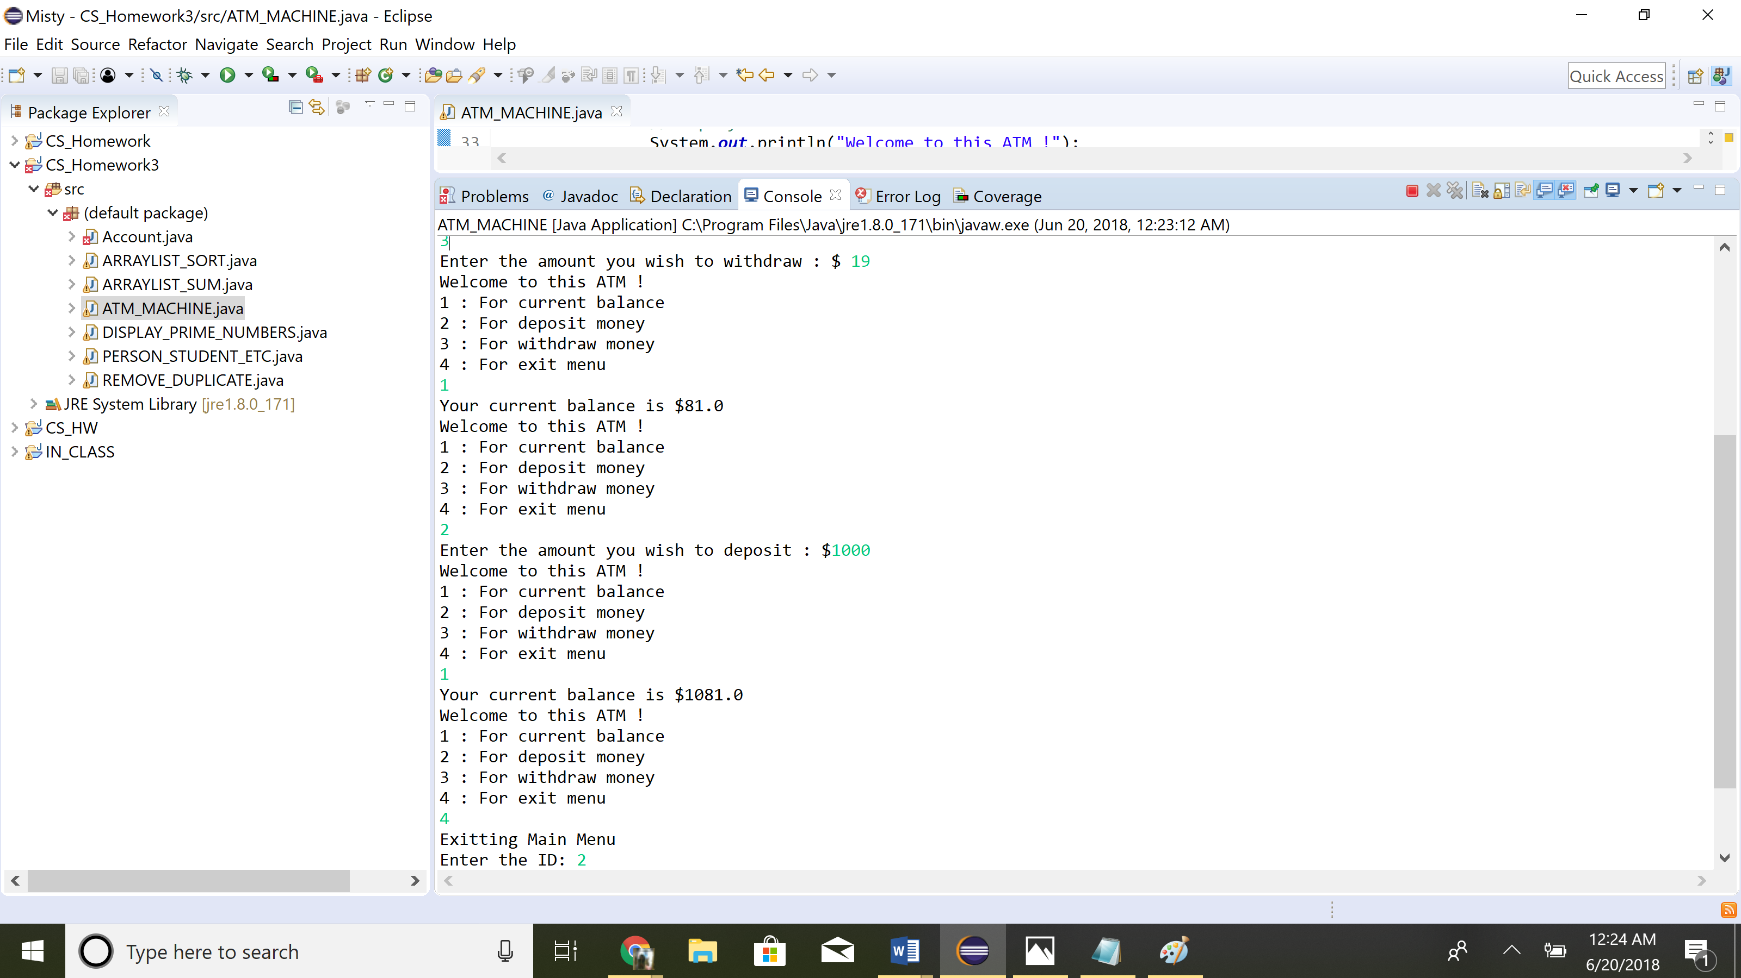

1. You can use a classic array or array list
2. Create 10 accounts in an array with id and initial balance $100.
3. Prompt user for id
   1. Accepted id => show main menu
4. After exit menu, prompt for id again

**Exercise 10.8 : Tax Class (Extra Credit)**

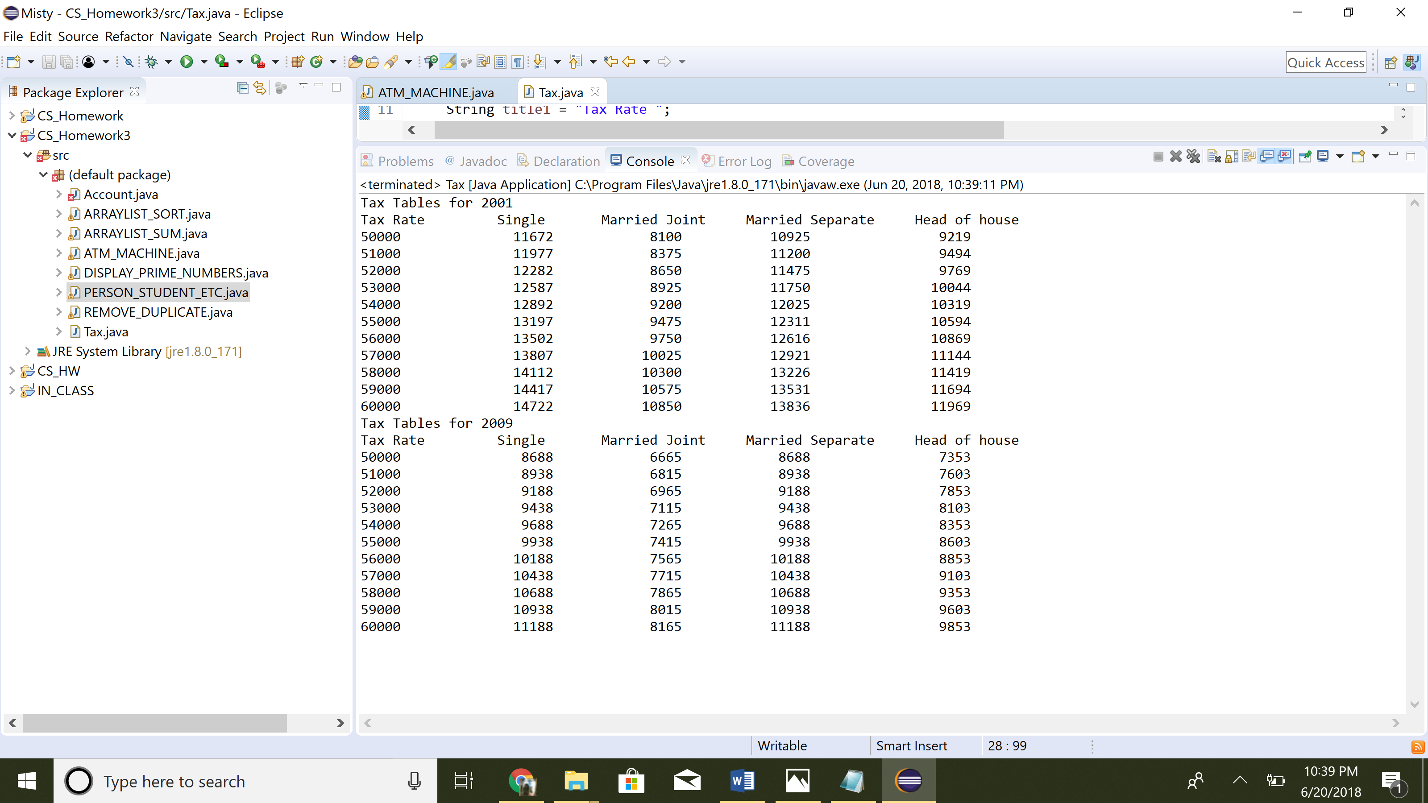

1. Provide getter & setter methods for each data field
2. getTax() : returns tax
3. no-arg constructor & constructor
   1. Tax( filingStatus, brackets, rates, taxableIncome)
4. Use tables from book to get info for 2001 and 2009
   1. Make tax tables for both years

**Exercise 11.2 : Person, Student, Employee, Faculty, Staff Class**

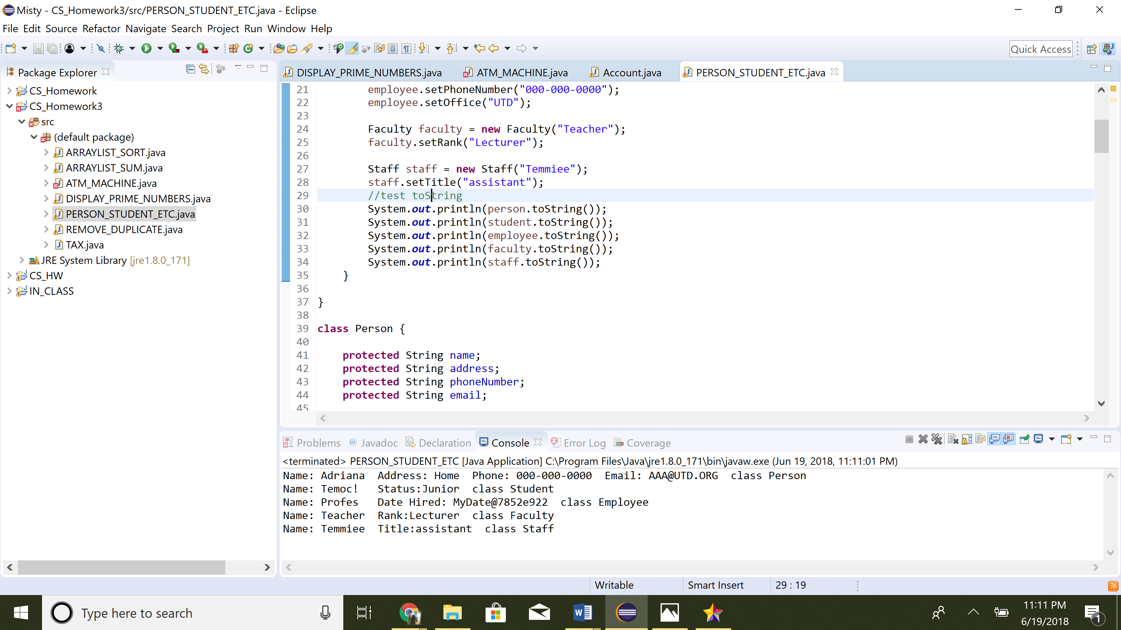

1. Create UML Diagrams for the classes
2. Person has 2 subclasses : Student , Employee
3. Person has : Name, Address, Phone number, Email Address
   1. Student has : class status (define as constant)
   2. Employee has : office, salary and date hired

**Exercise 11.11 : ArrayList Sort**

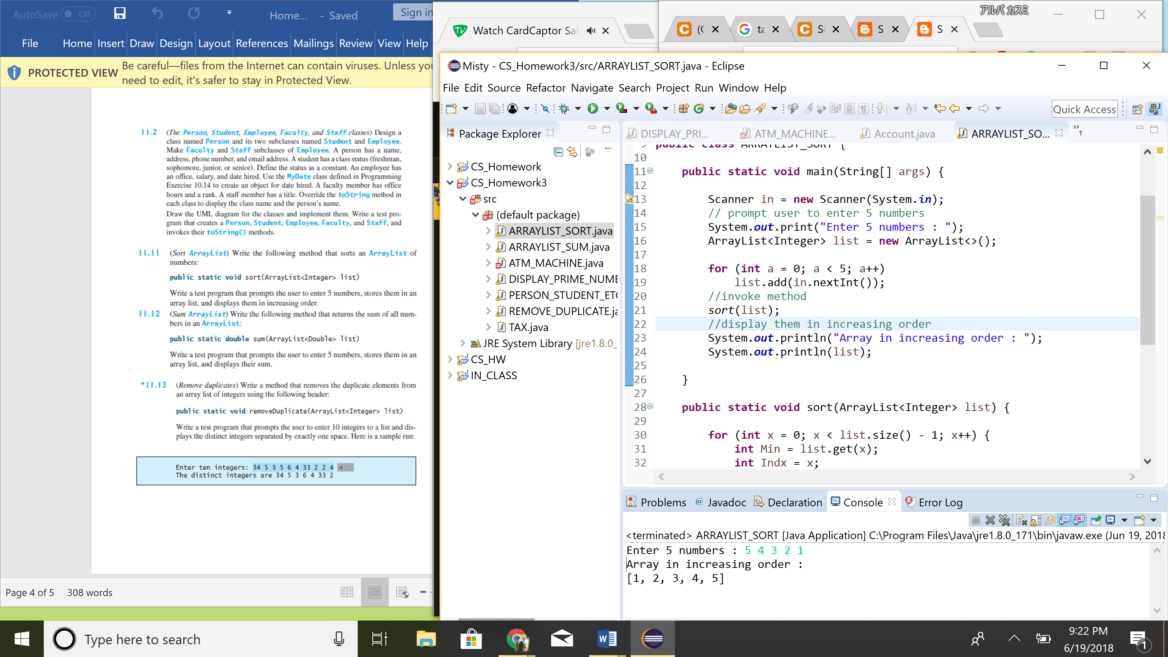

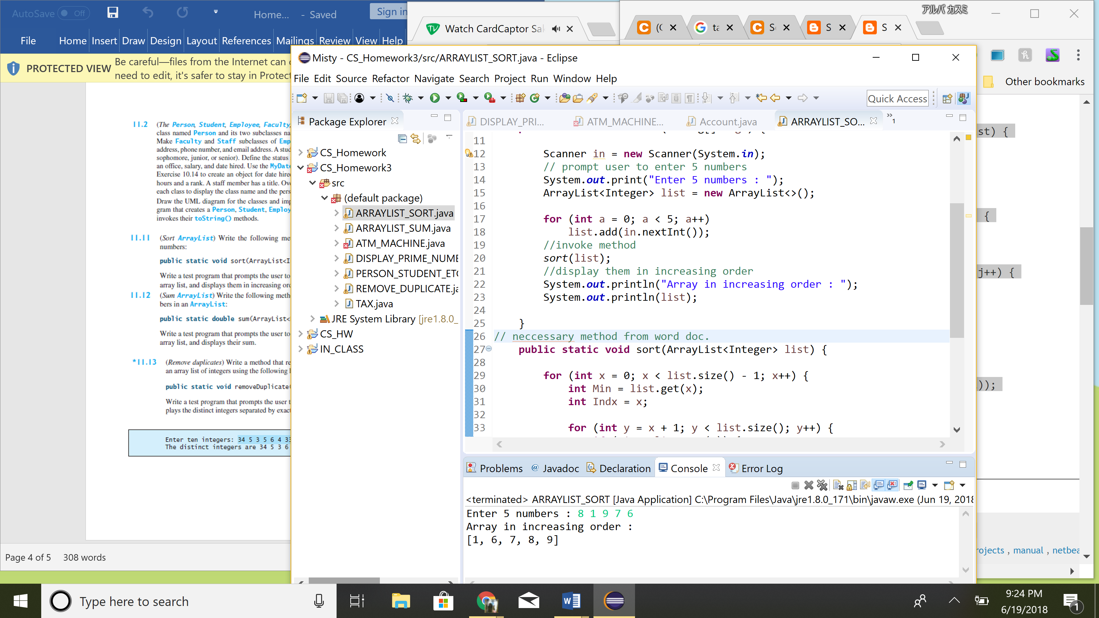

1. Have method public static void sort(ArrayList<Integer> list)

**Exercise 11.12 : ArrayList Sum**

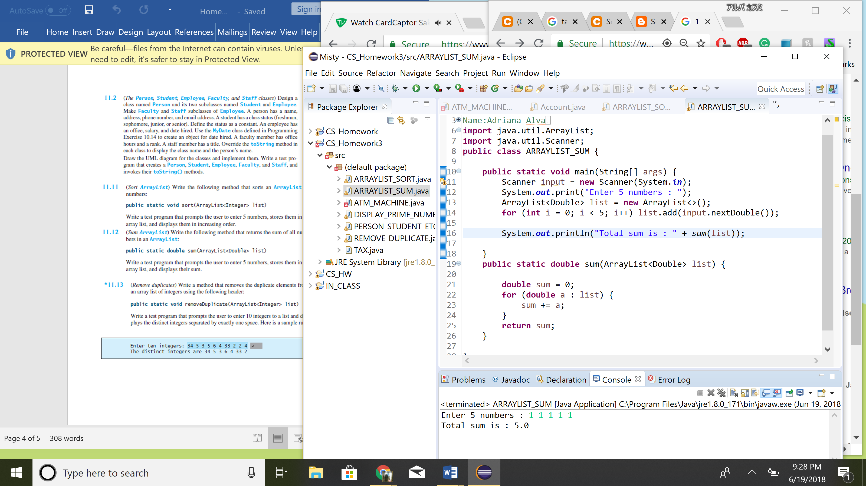

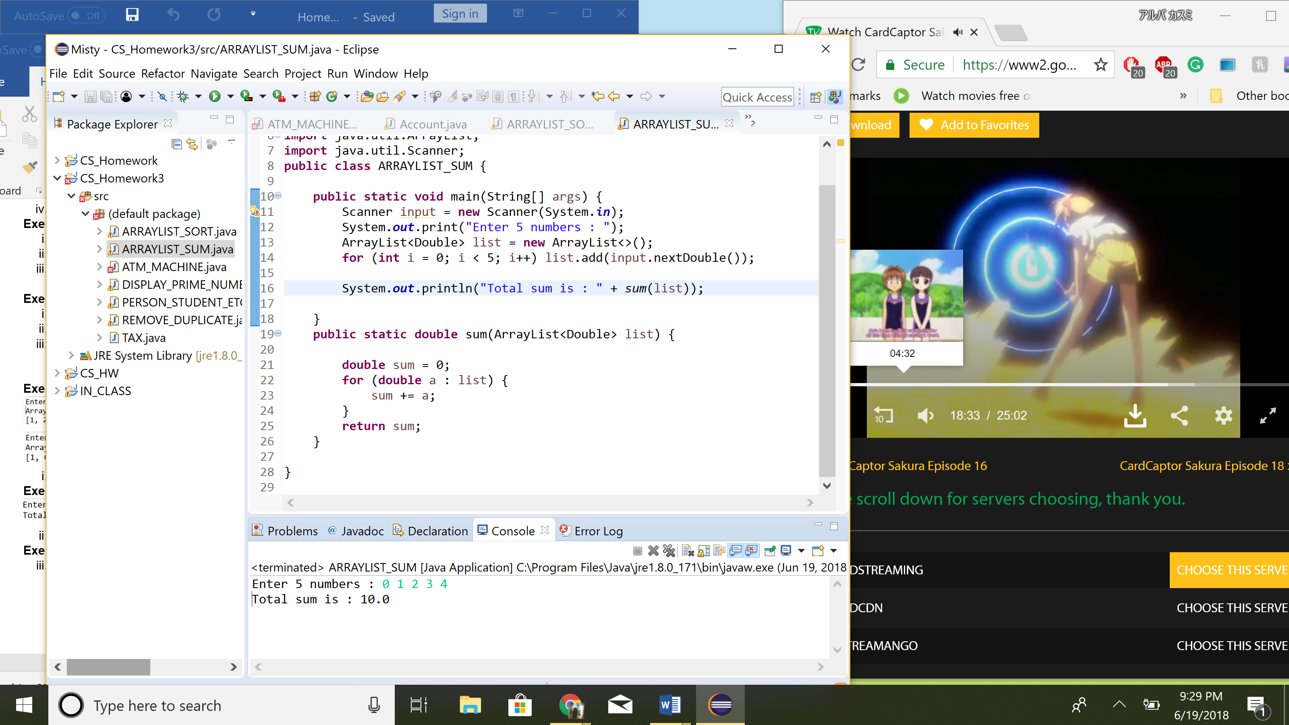

1. Have method public static void sum(ArrayList<Double> list)

**Exercise 11.13 : Remove duplicate**

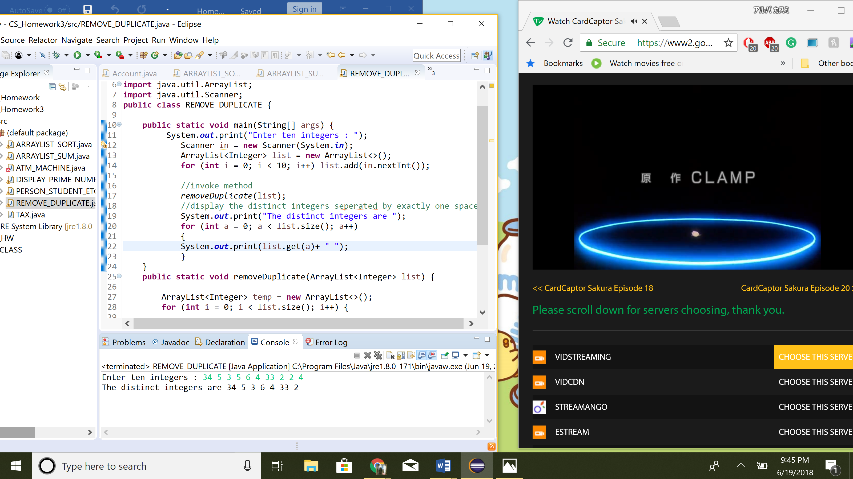

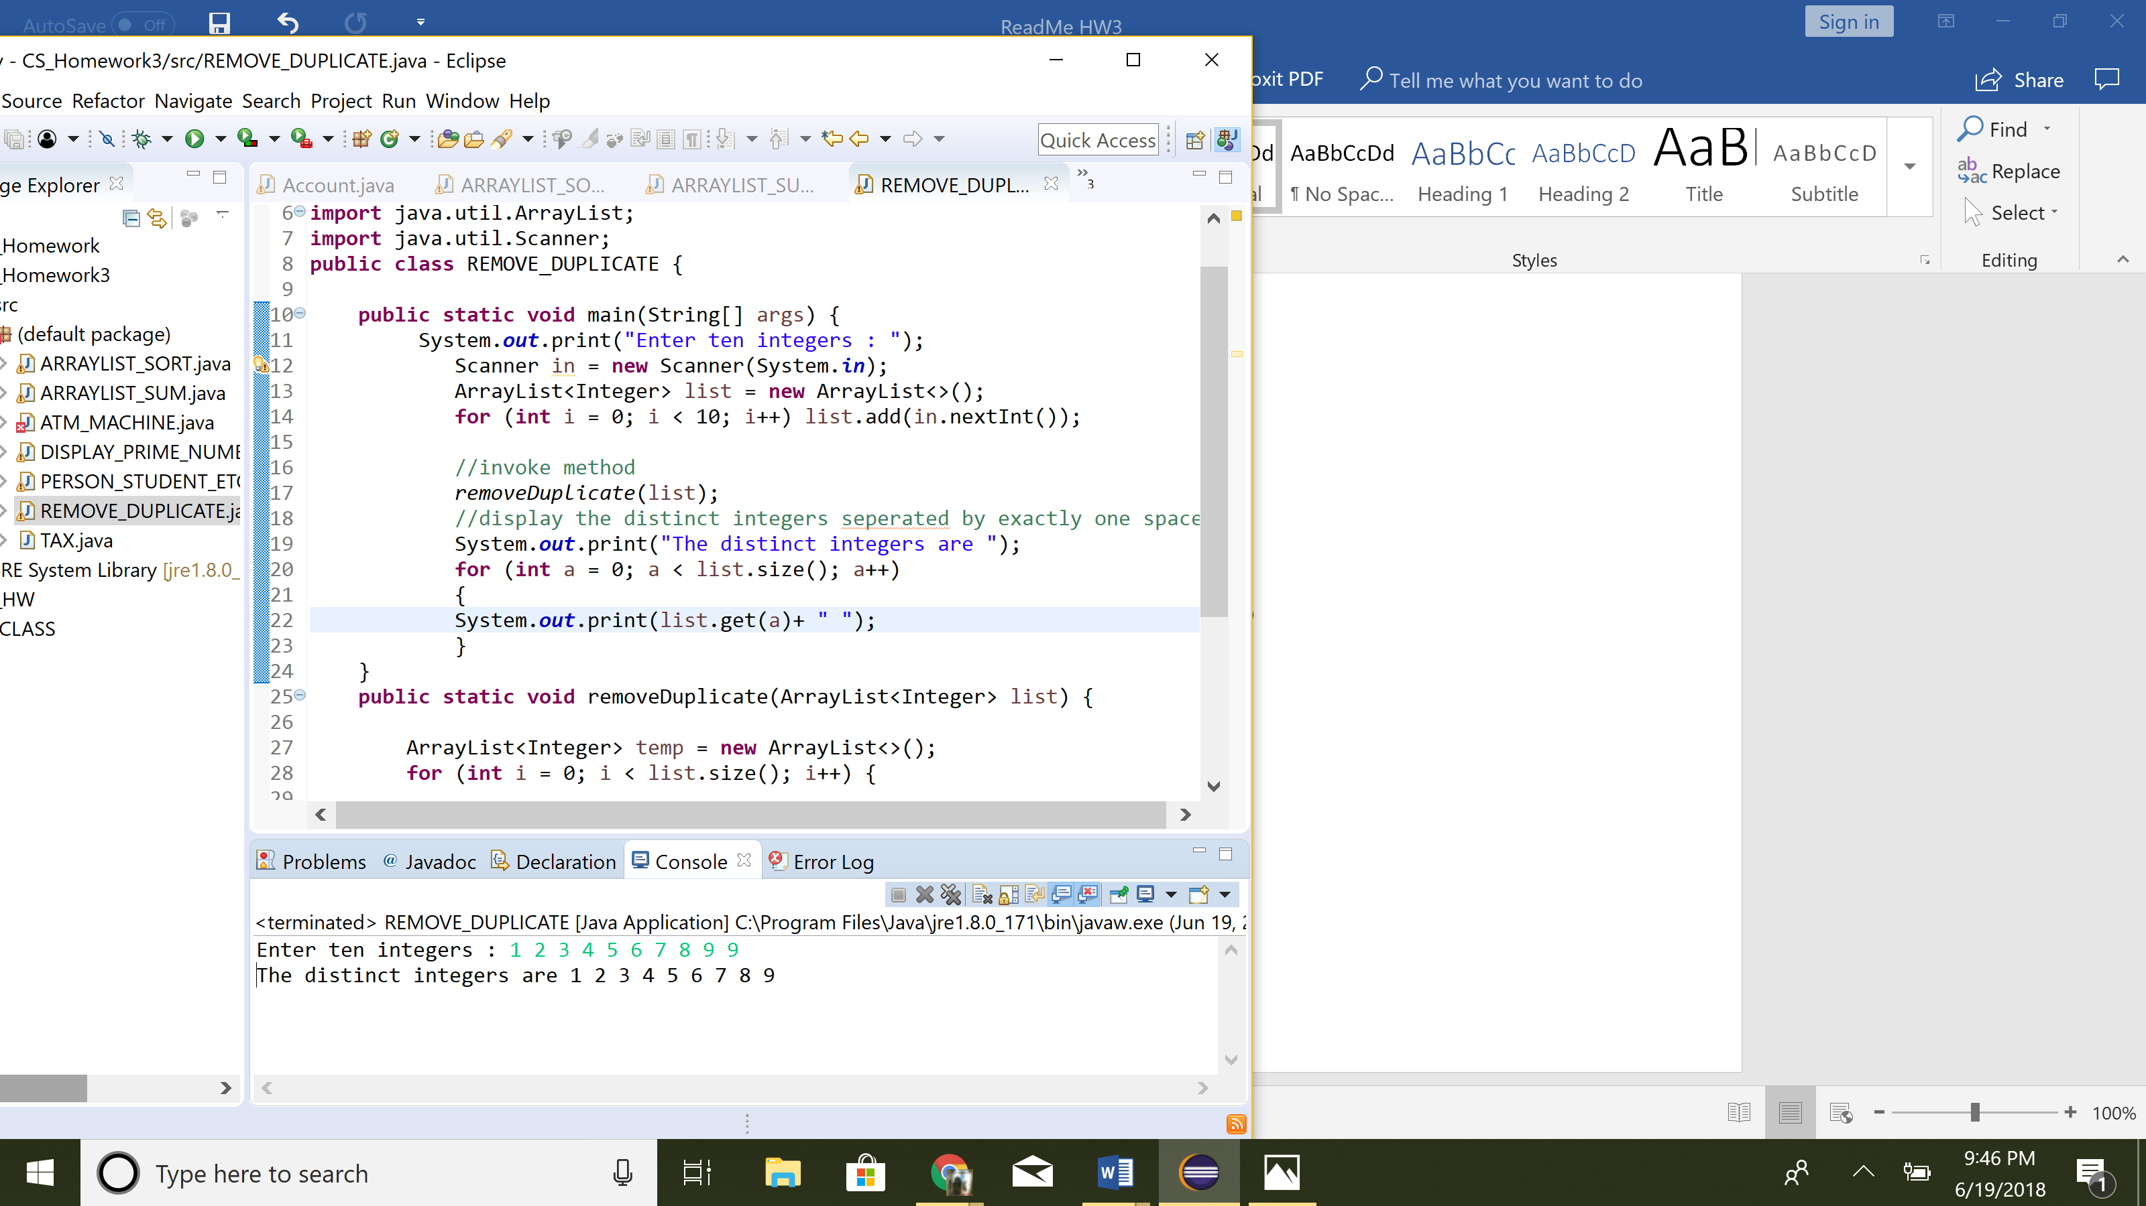

1. Have method public static void removeDuplicate(ArrayList<Integer> list)